## AFRA AYAZ SIMRA MAJEED

**A project report submitted in partial fulfilment of the Requirements for the award of the degree of Bachelor of Information Technology (BSIT)**

### Computer Science Department Bahria University, Karachi Campus

**2025**

# DECLARATION

We hereby declare that this project report is based on our original work except for citations and quotations which have been duly acknowledged. We also declare that it has not been previously and concurrently submitted for any other degree or award at Bahria University or other institutions.

|  |  |
| --- | --- |
| Signature : | _________________________ |
| Name : | _________________________ |
| Reg No. : | _________________________ |
| Signature : | _________________________ |
| Name : | _________________________ |
| Reg No. : | _________________________ |
| Date : | _________________________ |

# APPROVAL FOR SUBMISSION

We certify that this project report entitled **“BLOGFUSION: Combining**

### Automation with Manual Creativity” was prepared by Afra Ayaz & Simra Majeed has met the required standard for submission in partial fulfilment of the requirements for the award of Bachelor of Information Technology at Bahria University.

Approved by,

Signature : _________________________

Supervisor : Miss Reema Qaiser Khan

Date : 28-jan-2025

The copyright of this report belongs to Bahria University according to the Intellectual Property Policy of Bahria University BUORIC-P15 amended on April 2019. Due acknowledgement shall always be made of the use of any material contained in, or derived from, this report.

© 2019 Bahria University. All right reserved.

# ACKNOWLEDGEMENTS

We would like to thank everyone who had contributed to the successful completion of this project. We would like to express my gratitude to my research supervisor, Miss **Reema Qaiser Khan** for her invaluable advice, guidance and her enormous patience throughout the development of the research.

## BlogFusion: Combining Automation with Manual Creativity

# ABSTRACT

BlockFusion is a user-friendly blogging platform built to make content creation easy and flexible. It offers two main ways to create blogs: manually and automatically. With the manual option, users can write and publish their own blogs, which will stay live for up to 60 days. After that, if they want their blogs to stay visible longer, they can upgrade to our subscription model for more features and extended visibility. For those who prefer an automated approach, BlockFusion's cutting-edge technology will generate and optimize blogs based on user preferences. This platform is designed to help individuals and businesses manage and grow their online presence effortlessly, while making it easier to create and share content that truly resonates.

Table of content

DECLARATION 2

APPROVAL FOR SUBMISSION 3

ACKNOWLEDGEMENTS 4

ABSTRACT 5

CHAPTER 1 7

1 INTRODUCTION 7

CHAPTER 2 9

Evolution of Blogging Platforms 9

CHAPTER 3 11

DESIGN AND METHODOLOGY 11

1. User Registration & Login: 11

2. Blog Creation (Manual): 11

3. Blog Generation (Automated): 12

4. Subscription & Extended Visibility: 12

5. Blog Management & Analytics: 12

REFERENCES 16

# CHAPTER 1

# 1 INTRODUCTION

###### 1.1 Background

In today’s world, blogging has become a powerful tool for people to share their ideas, knowledge, and connect with others. But even though starting a blog is easy, creating consistent, high-quality content can be a real challenge. Many people find it hard to

come up with fresh ideas or simply don’t have the time to write regularly. That's where BlockFusion comes in. Our platform combines the flexibility of manual blogging with the speed and efficiency of automated content generation, helping users create and manage their blogs effortlessly.

###### 1.2 Problem Statements

There’s a lot of content out there on the internet, which makes it tough for anyone to stand out. Whether you're an individual blogger or a business, it’s easy to get lost in the noise. Many platforms either let you write your blog from scratch or rely entirely on automation, but they don’t offer a perfect balance of both. This can leave users feeling stuck – they either spend too much time writing or rely on generic, robotic content. We wanted to solve this by offering a platform that gives the best of both worlds.

###### 1.3 Aims and Objectives

The main goal of BlockFusion is to give users an easy and flexible way to create blogs.

Our key objectives are:

1. **Manual Blogging**: Allow users to write and publish their blogs in a simple,

intuitive way.

1. **Automated Blogging**: Offer an automation feature that generates blog posts

quickly, without compromising quality.

1. **Subscription Model**: Provide users with an option to upgrade for more features

and longer blog visibility.

1. **Engaging Content**: Help users create blogs that are engaging and optimized for search engines, ensuring they reach a larger audience.
2. **User-Friendly Experience**: Make sure the platform is easy to use for everyone, whether you're a beginner or an experienced blogger.

###### 1.4 Scope of Project

BlockFusion is designed for anyone looking to start or grow their blog – whether you're an individual or a business. Here is what our blogfusio will offer:

1. **Manual Blog Creation**: Users can write and publish their blogs manually. Once published, the blog will remain visible for up to 60 days, after which users can opt for a subscription to extend its reach and visibility.
2. **Automated Blog Generation**: For those who don’t have the time or need to write, the platform will automatically generate blogs based on user preferences hence making content creation faster and easier.
3. **Additional Features**: BlockFusion will also include useful tools like paraphraser and SEO optimization to help users track their blog’s performance and improve visibility.

# 

# CHAPTER 2

# Evolution of Blogging Platforms

Platforms for blogging have changed dramatically over time. Platforms like WordPress and Blogger started out as straightforward instruments for individual expression but eventually evolved to satisfy the demands of marketers and companies. Blogging has evolved into a potent tool for content marketing and search engine optimization, not only for sharing personal tales. Users have the option of creating their own blogs or letting the system create content for them thanks to contemporary platforms like our platform BlogFusion, which blend automatic and manual content generation. By introducing tools like trending blogs, users can stay up to date on the latest trends in their field, which improves engagement and makes the material more relevant.

1. **Manual vs. Automated Blogging Services:**

There are two ways of doing blogging: you can do it manually or use automation. With manual blogging, you get complete control-you write your posts at your convenience and maintain the personal touch and unique voice. It is fine-tuned if you want to create a real connect with your audience. Automated, however, relies on AI to generate content, saving a lot of time. This is especially helpful if you need to publish a lot of content consistently. Our BlogFusion platform blends the best of both worlds by letting you choose between writing your own blogs or letting the system do it for you. Plus, it offers SEO optimization and helps manage keywords, ensuring your content gets noticed. The added bonus? A trending blogs feature that keeps you in the loop with what's currently popular, so you can create content that hits the mark.

1. **Impact of Content Personalization and SEO Optimization**

SEO optimization and content personalization are the key to increasing visibility and engagement. Techniques such as keyword use, backlinks, and content structuring help blogs rank higher on search engines. Meanwhile, personalization ensures that the content resonates with the reader's interests. Our BlogFusion platform supports both these aspects by offering tools to optimize content for SEO while allowing users to tailor their posts for their target audience. The addition of the trending blogs in our platform keeps content fresh and aligned with what's popular, ensuring that users stay relevant in a competitive online environment.

1. **User-Generated Content and SEO Synergy:**

One of the strengths of our **BlogFusion** platform is its ability to leverage usergenerated content (UGC) to improve SEO performance. As users create content, the platform encourages them to incorporate trending keywords and relevant topics, which naturally boosts search engine visibility. Additionally, UGC fosters a sense of community, with readers interacting through likes, comments, and shares, further amplifying SEO. This creates a powerful cycle where user engagement enhances the SEO performance of the content, and better SEO results lead to increased user visibility and interaction.

1. **Automated Content Optimization for Faster Results**

Not everyone has the time to dive deep into SEO, so our **BlogFusion** makes it easy with automated content optimization features. The platform automatically analyzes blog content and provides real-time suggestions for improving SEO, like adding keywords, refining meta descriptions, or optimizing image ALT texts. This automation makes it easy for users to ensure their content is SEO-friendly without needing to be SEO experts. With this system in place, users can focus on creating high-quality, engaging content while **BlogFusion** ensures their posts perform well in search engine rankings.

1. **Trends in Blogging and User Engagement**

User engagement is a huge trend in blogging today. People don't just want to read-they want to interact, share opinions, and be part of the conversation. Our BlogFusion platform taps into this by offering options for likes, comments, and sharing, which allow readers to engage directly with the content. Our platform tracks these interactions, and blogs with the highest number of likes, comments, and shares are featured in the trending blogs section. This helps users discover popular topics and connect with content that resonates with others in their niche. By focusing on engagement, Our BlogFusion Platform boosts traffic, encourages more participation, and keeps users coming back for fresh, trending content.

# CHAPTER 3

# DESIGN AND METHODOLOGY

1. **ROPOSED METHODOLOGY (FRAMEWORK/ARCHITECTURE)**

For BlockFusion, we have adopted a flexible and user-centered approach in designing the platform. The project is built using **Next.js** for the frontend, providing fast, responsive, and dynamic pages, while **React** ensures a smooth and interactive user experience. For the backend and database management, we have used **Firebase** which offerssecure user authentication, real-time data storage, and seamless scalability. Our architecture follows a **modular** structure, with clear separation between different components to ensure that the platform is scalable and maintainable. The system includes modules for manual blog writing, automated content generation, and a user management system to handle subscriptions and authentication.

1. **PROCESS MODEL**

The Process Model of BlockFusion outlines how our platform works step-by-step to ensure a smooth and efficient experience for our users. It's designed to simplify the journey from creating a blog to publishing it and managing its visibility.

Here’s a breakdown of how the process flows:

1. **User Registration & Login**:

a. First users will sign up or log in through Firebase Authentication which ensures secure access and a personalized experience for each user.

1. **Blog Creation (Manual)**:
   * + 1. Once a user is logged in so they can start writing their blog posts manually using our platform’s easy-to-use text-editor that provides rich text formatting and other features such as insert an image or embed link to enhance the content.
       2. After writing users can preview, make edits after that publish their blog, which will remain live for 60 days (stated by client) unless they choose to subscribe for extended visibility.
2. **Blog Generation (Automated)**:
   * + 1. For users who want a faster way to create content, the **automated blog generation** feature is available, but only to those with a **paid subscription**.

With this feature, users can input a topic or keywords, and the system will generate a fully written blog post.

* + - 1. Moreover, our platform checks for plagiarism and paraphrases any generated content to ensure originality which allows users to publish content confidently.

1. **Subscription & Extended Visibility**:

a. If our users want more control over their blogs, such as keeping them visible beyond 60 days so they can choose to subscribe to a paid plan which includes the automated blog generation tool, provides more flexibility and additional premium features like better visibility and access to paraphrasing tool. Moreover, subscription provides additional features, such as extended visibility for blogs and priority support.

1. **Blog Management & Analytics**:

a. Users can manage their blogs through a simple dashboard, where they can view all their blog post, track performance such as no of likes, comments and shares, make necessary updates.

1. **MODULES DISCUSSION**
2. Manual Blog Writing (Rich Editor): In this method, the writer has full control over the blog content. You, as the writer, manually add the SEO elements like target keywords, headings, meta descriptions, and internal/external links. You can also carefully adjust the tone, style, and keyword placement for better search rankings. This allows for creative and tailored optimization, but it requires time and effort from the writer.
3. Automated Blog Writing A: In this method, the AI asks you specific questions, like your target audience, country, keywords, and their URLs. Based on user input the AI will generate a complete blog with optimized content also includes the keywords, adjusts their placement and even rephrases content to ensure variety. moreover, AI also handles finishing touches like adding links, anchor texts, and alt texts, making it a faster and automated SEO process.

1. **PROJECT DIAGRAM**

The project architecture is structured around a **frontend-backend** model where the frontend (Next.js and React) interacts with the backend (Firebase) via firebase SDK.

The diagram below outlines how these components interact:

* **Frontend**: it displays the UI for users to write blogs, publish them generate automated blogs.
* **Backend**: Handles user authentication, stores blog content, and manages subscriptions.
* **Firebase**: Acts as the database, storing user data, blog content, and managing real-time updates.

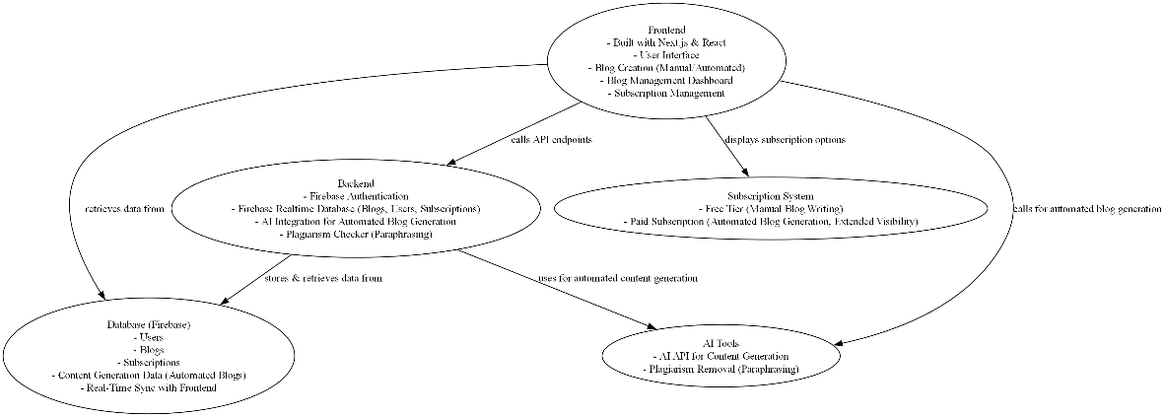

1. **DATABASE DESIGN (ERD)**

We’ve structured our database with Firebase to support the following main entities:

1. **Users**: Stores the user details such as their email, password, subscription status, and roles.
2. **Blogs**: Each blog entry stores the content, author information, publication date, time and visibility status of their blog.
3. **Subscriptions**: It will keep track of our user’s subscription plan, expiry date, and related benefits.
4. **Automated Content**: It will store the generated blog content and its original input parameters such as (topic, keywords).

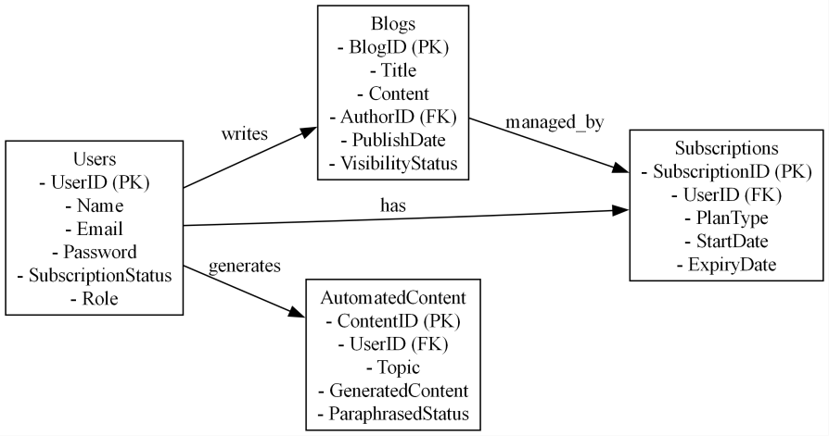

1. **SEQUENCE**

The sequence diagram illustrates the interaction between the user, the frontend, the backend, and Firebase. For example:

1. The user logs in or signs up through Firebase Authentication.
2. The user writes or generates a blog.
3. The blog content is saved to Firebase in the Blogs collection.
4. Upon submission, the system checks the blog’s status, applies plagiarism removal (if automated), and schedules visibility (based on the user’s subscription).

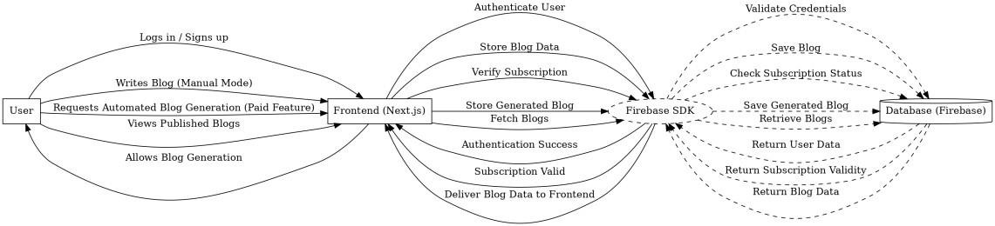

1. **CONTEXT DIAGRAM**

The context diagram gives us a high-level view of the BlogFusion and its interactions with external entities like users, Firebase, and other services. BlockFusion interacts with:

* **Users**: Who create and publish blogs.
* **Firebase**: For data storage, authentication, and real-time updates.
* **External APIs**: For automated blog generation and plagiarism detection (not implemented yet).

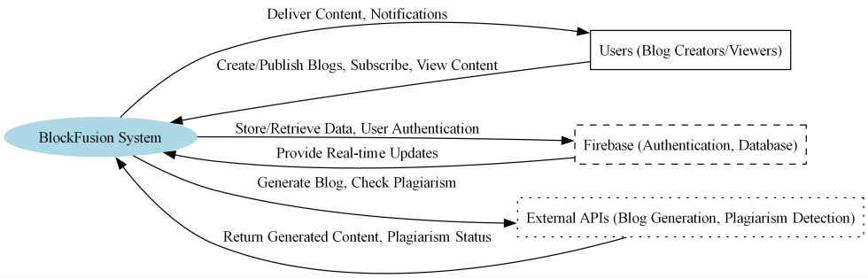

1. **USE CASES**

The key use cases for BlockFusion will be:

1. **User Registration and Authentication**: Users can sign up or log in using Firebase Authentication.
2. **Manual Blog Creation**: Users can write, edit, and publish their blogs.
3. **Automated Blog Generation**: Users input a topic, and the platform generates a blog automatically based on refined prompt.
4. **Plagiarism Removal**: Automated blogs will be paraphrased to ensure originality before publishing.
5. **Subscription Management**: Users will be able to upgrade to subscription for extended visibility and additional features.
6. **Blog Analytics**: Users will be able track the performance (likes, comments, shares) and traffic of their published blogs.

# REFERENCES

1. <https://nextjs.org/docs>
2. <https://tailwindcss.com/docs/installation/using-vite>
3. <https://www.forbes.com/>
4. <https://medium.com/>
5. <https://console.firebase.google.com/u/0/>
6. <https://console.firebase.google.com/u/0/>
7. <https://www.postman.com/api-platform/api-integration/>
8. <https://www.emailjs.com/docs/>
9. <https://sweetalert2.github.io/>
10. <https://github.com/>
11. <https://vercel.com/docs>
12. <https://docs.npmjs.com/>